**CHAPTER 1**

**ABSTRACT:**

Today, smart grid, smart homes, smart water networks, intelligent transportation, are infrastructure systems that connect our world more than we ever thought possible. The common vision of such systems is usually associated with one single concept, the Internet of Things (IoT), where through the use of sensors, the entire physical infrastructure is closely coupled with information and communication technologies; where intelligent monitoring and management can be achieved via the usage of networked embedded devices. These devices will connect to internet to share different types of data.

Internet of things(ioT) is rapidly increasing technology.IOT is the network of physical objects or things embedded with electronic software, sensors, and network connectivity which enables these objects to collect and exchange data. In this paper, we are developing a system which will automatically monitor the industrial applications and generate Alerts/Alarms or take intelligent decisions using concept of IoT.

Safety from leaking of raw gas and fire are the most important requirements of home and industries security system for people. A traditional security system gives the signals in terms of alarm.

**CHAPTER 2**

**INTRODUCTION:**

Automation is one of the increasing needs with in industries as well as for domestic applications. Automation reduces the human efforts by replacing the human efforts by system which is self-operated.

The Internet is one way of the growing platform for automation, through which new advancement is made through which on easily monitor as well control the system using internet. As we are making use of Internet the system becomes secured and live data monitoring is also possible using IoT system.

Within industries the various hazardous gas are being processed, hence to provide security to those employ working within those industries, it becomes important issue to work on their security, If leakage of gas takes place then these system alerts by turning ON alarm which notifies the employers.

This system also helps us take some crucial decision from any point of the world within internet network.Wi-Fi shield is being used to act as service point between network and connecting network.

An emerging technology brought about rapid advances inmodern wireless telecommunication, Internet of Things (IoT) has attracted a lot of attention and it is expected to bring benefits to numerous application areas including industrial WSN systems, and healthcare systems manufacturing. Wireless sensor networks (WSN) have been employed to collect data about physical phenomena in various applications such as habitat monitoring, and ocean monitoring, and surveillance. WSN systems are well-suited for long-term industrial environmental data acquisition for IoT representation. Sensor interface device is essential for detecting various kinds of sensor data of industrial WSN in IoT environments. It enables us to acquire sensor data. Thus, we can better understand the outside environment information

**CHAPTER 3**

**LITERATURE SURVEY:**

“**Industrial Automation using IoT” International Research Journal of Engineering and Technology (IRJET).Volume: 04 Issue: 06 | June-2017**

To build the system which can monitor the sensor data and upload it over internet and also capable of taking some crucial decision within industries using the IoT.

“**IoT Based Industrial Parameters Monitoring and Alarming System using Arduino” International Journal of Engineering Science and Computing, April 2018**

systems is usually associated with one single concept, the Internet of Things (IoT), where through the use of sensors, the entire physical infrastructure is closely coupled with information and communication technologies; where intelligent monitoring and management can be achieved via the usage of networked embedded devices.

**“Complete Industrial Solution for Automation in Temperature and Humidity Monitoring using Lab VIEW”**

The system provides for remote monitoring of the temperature and humidity levels of different parts of the plant with the help of the sensors and is based on lab View software platform.

**CHAPTER 4**

**BLOCK DIAGRAM:**

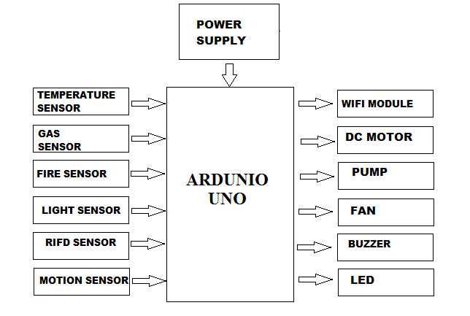

**Fig no.1: BLOCK DIAGRAM**

**CHAPTER 4.1**

**WIRING DIAGRAM:**

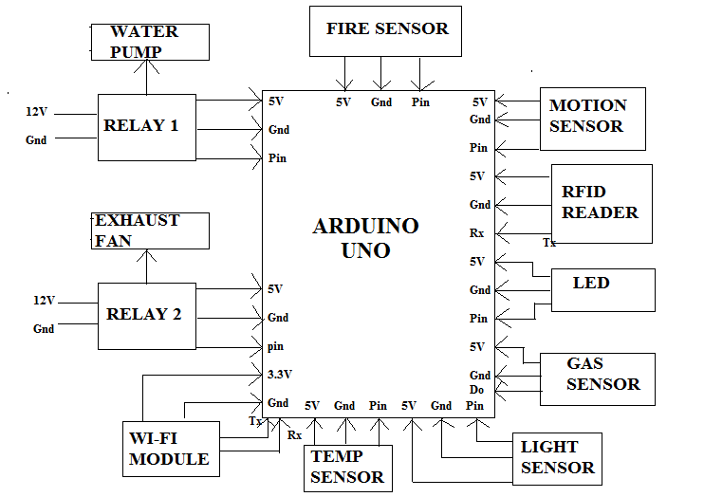

**Fig no.2: WIRING DIAGRAM**

**CHAPTER 4.2**

**WORKING:**

Arduino is a open source electronics prototyping platform based on flexible,easy-to-use hardware and software.It’s intended for artists,designers,hobbyists,and anyone interested in creating interactive objects or environments.It’s an open-source physical computing platform based on a microcontroller board,and a development environment for writing software for the board.

In simple words,Arduino is a small microcontroller board with a USB plug to connect to your computer and a number of connection sockets that can be wired up to diodes,loudspeakers,microphones, etc. ,They can either be powered through the USB connection from the computer or from a 9V battery.They can be controlled from the computer or programmed by the computer and then disconnected and allowed to work independently.

Anyone can buy this device through online auction site or search engine.Since the Arduino is an open-source hardware designs and ccreate their own clones of the Arduino and sell them,so the market for the boards is competitive.An official Arduino costs about $30,and a clone often less than $20.

The name “Arduino” is reserved by the original makers. However, clone Arduino designs often.

have the letters “duino” on the end of their name, for example, Freeduino or DFRduino. The software for programming your Arduino is easy to use and also freely available for Windows, Mac, and LINUX computers at no cost.

Microcontroller can be described as a computer embedded on a rather small circuit board.To describe the function of a microcontroller more precisely,it is a single chip that can perform various calculations and tasks,and send/receive signals from other devices via the available pins. Precisely what tasks and

communication with the world it does, is what is governed by what instructions we give to the Microcontroller. It is this job of telling the chip what to do, is what we refer to as programming on it.

However, the uC by itself, cannot accomplish much; it needs several external inputs: power, for one; a steady clock signal, for another. Also, the job of programming it has to be accomplished by an external circuit. So typically, a uC is used along with a circuit which provides these things to it; this combination is called a microcontroller board. The Arduino Uno that you have recieved, is one such microcontroller board. The actual microcontroller at its heart is the chip called **Atmega328**. The advantages that Arduino offers over other microcontroller boards are largely in terms of reliability of the circuit hardware as well as the ease of programming and using it.

Open-source hardware shares much of the principles and approach of free and open-source software.The founders of Arduino wanted people to study their hardware,to understand how it works,make changes to it,and share those changes with the world.To facilitate this,they release all of the original design files(Eagle CAD)for the Arduino hardware.These files are licensed under a Creative Common Attribution Share-Alike license,which allows for both personal and commercial derivative works,as long as they(people) credit Arduino and release their designs under the same license.

A sensor interface device is essential for sensor data collection of industrial wireless sensor networks (WSN) in IoT environments. WIRELESS SENSOR NETWORKS (WSN) has been employed to collect data about physical phenomena in various applications such as habitat monitoring, and ocean monitoring, and surveillance. As an emerging technology brought about rapid advances inmodern wireless telecommunication, Internet of Things (IoT) has attracted a lot of attention andis expected to bring benefits to numerous application areas including industrial WSN systems, and healthcare systems manufacturing. WSN systems are well-suited for long-term industrial environmental data acquisition for IoT representation. Sensor interface device is essential for detecting various kinds of sensor data of industrial WSN in IoT environments. It enables us to acquire sensor data. Thus, we can better understand the outside environment information. However, in order to meet the requirements of long-termindustrial environmental data acquisition in the IoT, the acquisition interface device can collect multiple sensor data at the same time, so that more accurate and diverse data information can be collected from industrial WSN.

All the sensor inputs and sensor outputs are coded in the Arduino Uno Microcontroller Chip and the data are dumped in it. Whenever any sensor is functioning, an alert is sent to the TCP/UDP TEST TOOL Application in our mobiles through the Wi-Fi Signal present in our Model Design. The Wi-Fi range of our module is 10 meters. Though the errors occurred in the factory is sensed and rectified by automation, an immediate alert is sent in our mobile application so as to know the mishaps happening in the factory and prevent such mishaps in the future. The various sensors used, their input and outputs, and what results we incur from them are briefly listed below.

RFID Sensor along with Motion Sensor,The Input We swipe an RFID card on the RFID reader,the OutputAs soon as the sensor identifies the card number, the gate is opened and the person gets inside. After he gets inside, the motion sensor senses his/her presence and automatically closes the gate. We get an alert in the mobile application of the card number as who entered the premises. The Result IncurredWorkers who have access in the factory has their card numbers stored in the database. Outsiders cannot enter easily without authorization of the card or until their card number is stored in the database. Hence this system can be used as a safety system.

Fire Sensor, the Input We use a lighter near the fire sensor as the input. Output As soon as the sensor identifies the fire, immediately the buzzer alerts, the fan and the water pumps starts operating in order to extinguish the fire and the gate opens so that the workers can leave the factory premises. We get an alert in the mobile application as “fire alert”. Result Incurred This system can be used as an Automatic Fire Alert System.

Gas Sensor the Input - We use smoke emanating from the incense stick near the gas sensor as the input. Output As soon as the sensor identifies the smoke, immediately the buzzer alerts, and the fan starts operating in order to extinguish the smoke getting around and the gate opens so that the workers can leave the factory premises. We get an alert in the mobile application as “smoke detected”. Result Incurred This system can be used as Automatic Smoke Alert System.

Temperature Sensor , the Input We use the heat emanating from the incense stick near the temperature sensor as the input. Output As soon as the sensor identifies high temperature, the buzzer alerts and the fan starts operating in order to cool down the surrounding temperature. We get an alert in the mobile application as “temperature alert”.

Result Incurred , This system is mostly used in high temperature areas like boilers and power plants where the temperature is usually high. It is also used in normal temperature areas so that any changes in the temperature will alert the person present in the premises and they may avoid burns or other mishaps.

Light Sensor, the Input We cover the light sensor with our hands so that no light falls on the light sensor. Output As soon as the sensor identifies the dark surroundings, the LED present in the module lights up. Result Incurred This system is used in factories where lights are forever required.

**CHAPTER 5**

**HARDWARE COMPONENTS:**

**ARDUINO UNO:**

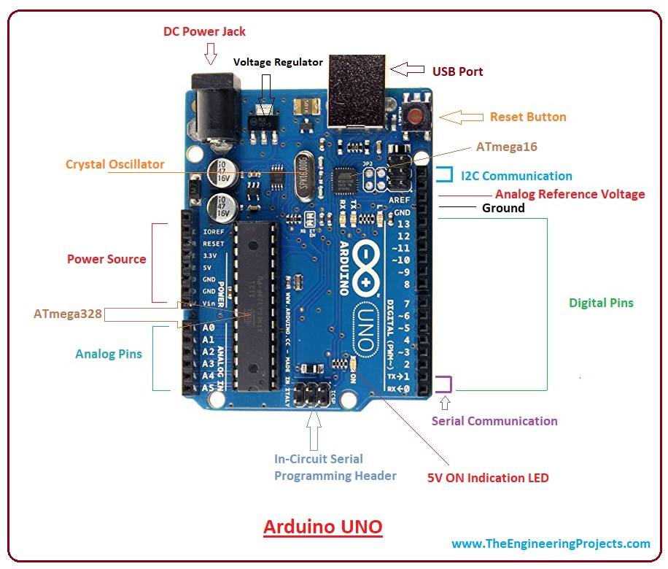

**Fig no.3: ARDUINO UNO**

Arduino is a open source electronics prototyping platform based on flexible, easy-to-use hardware and software. It’s intended for artists, designers, hobbyists, and anyone interested in creating interactive objects or environments. It’s an open-source physical computing platform based on a microcontroller board, and a development environment for writing software for the board.

In simple words, Arduino is a small microcontroller board with a USB plug to connect to your computer and a number of connection sockets that can be wired up to, such as external electronics, such as motors, relays, light sensors, laser diodes, loudspeakers, microphones, etc., They can either be powered through the USB connection from the computer or from a 9V battery. They can be controlled from the computer or programmed by the computer and then disconnected and allowed to work independently.

The name “Arduino” is reserved by the originalmakers. However, clone Arduino designs oftenhave the letters “duino” on the end of their name,for example, Freeduino or DFRduino.The software for programming your Arduino iseasy to use and also freely available for Windows,Mac, and LINUX computers at no cost.

**MICROCONTROLLER:**

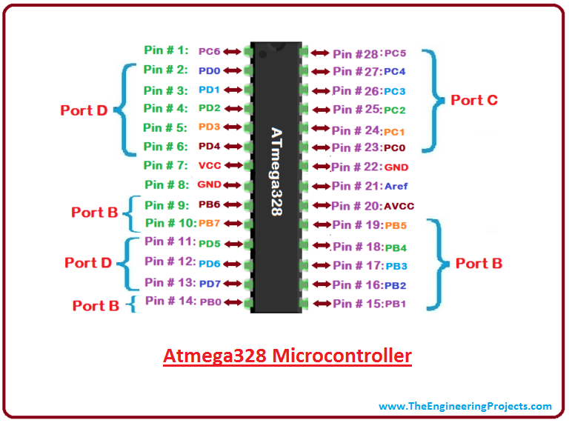

**Fig no.4: ATMEGA328 MICROCONTROLLER**

Microcontroller can be described as a computer embedded on a rather small circuit board. To describe the function of a microcontroller more precisely, it is a single chip that can perform various calculations and tasks, and send/receive signals from other devices via the available pins.Precisely what tasks andcommunication with the world it does, is what is governed by what instructions we give to the Microcontroller.

However, the uC by itself cannot accomplish much; it needs several externalinputs: power, for one; a steady clock signal, for another. Also, the job of programming ithas to be accomplished by an external circuit. So typically, a uC is used along with a circuitwhich provides these things to it; this combination is called a microcontroller board.The Arduino Uno that you have received is one such microcontroller board. The actual microcontroller at its heart is the chip called **Atmega328**. The advantages that Arduino offers over other microcontroller boards are largely in terms of reliability of the circuit hardware as well asthe ease of programming and using it.

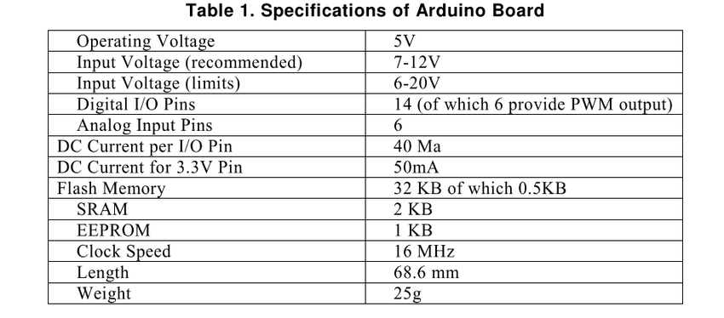

**TYPES OF ADRUINO:**

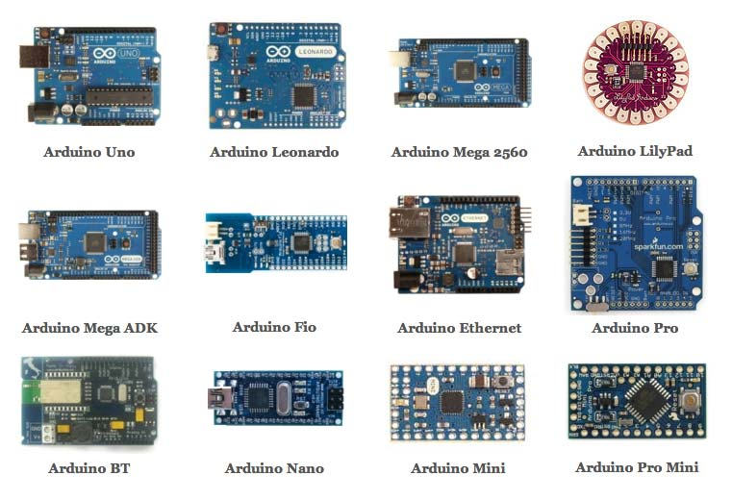

**Fig no.5: TYPES OF ADRUINO**

**POWER SUPPLY:**

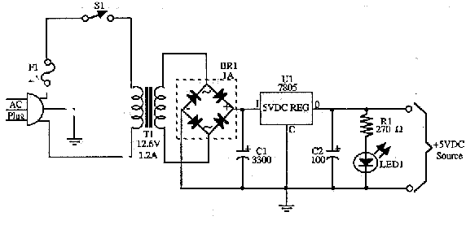

**Fig no.6: POWER SUPPLY**

The input to the circuit is applied from the regulated power supply. The a.c. input i.e., 230V from the mains supply is step down by the transformer to 12V and is fed to a rectifier. The output obtained from the rectifier is a pulsating d.c voltage. So in order to get a pure d.c voltage, the output voltage from the rectifier is fed to a filter to remove any a.c components present even after rectification. Now, this voltage is given to a voltage regulator to obtain a pure constant dc voltage.

**VOLTAGE REGULATER:**

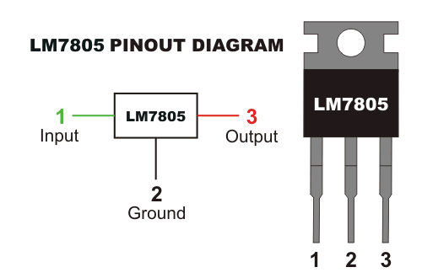

**Fig no.7: VOLTAGE REGULATER**

As the name itself implies, it regulates the input applied to it. A voltage regulator is an electrical regulator designed to automatically maintain a constant voltage level. In this project, power supply of 5V and 12V are required. In order to obtain these voltage levels, 7805 and 7812 voltage regulators are to be used. The first number 78 represents positive supply and the numbers 05, 12 represent the required output voltage levels. A variable regulated power supply, also called a variable bench power supply, is one where you can continuously adjust the output voltage to your requirements. Varying the output of the power supply is the recommended way to test a project after having double checked parts placement against circuit drawings and the parts placement guide.

This type of regulation is ideal for having a simple variable bench power supply. Actually this is quite important because one of the first projects a hobbyist should undertake is the construction of a variable regulated power supply. While a dedicated supply is quite handy e.g. 5V or 12V, it's much handier to have a variable supply on hand, especially for testing. Most digital logic circuits and processors need a 5-volt power supply. To use these parts we need to build a regulated 5-volt source. Usually you start with an unregulated power supply ranging from 9 volts to 24 volts DC (A 12 volt power supply is included with the [Beginner Kit](http://www.iguanalabs.com/1stled.htm) and the [Microcontroller Beginner Kit](http://www.iguanalabs.com/mbkit.htm).). To make a 5 volt power supply, we use a LM7805 voltage regulator IC (IntegratedCircuit).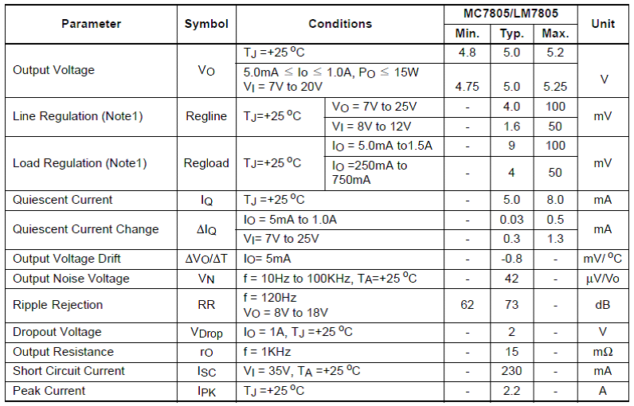

Electrical characteristics of LM7805

**FIRE SENSOR:**

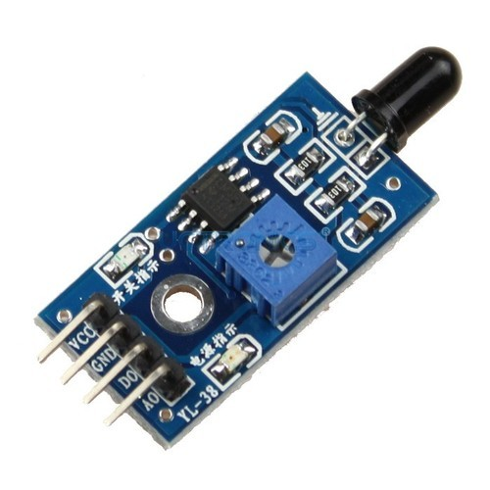

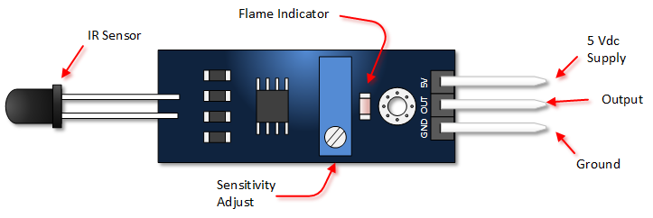

**Fig no.8: FIRE SENSOR PIN DESCRIPTION**

FIRE SENSOR SPECIFICATIONS:

LM393 comparator chip

Detection Range: 760 nm to 1100 nm

Operating Voltage: 3.3 V to 5 V

Maximum Output Current: 15 mA

Digital Outputs: 0 and 1

Detection Angle: about 60 degrees

Adjustable sensitivity

LED lights indicators: power (red) and digital switching output (green)

Fixed bolt holes for easy installation

PCB Size: 32 x 14 mm

A **flame detector** is a [sensor](https://en.wikipedia.org/wiki/Sensor) designed to detect and respond to the presence of a [flame](https://en.wikipedia.org/wiki/Flame) or [fire](https://en.wikipedia.org/wiki/Fire), allowing **flame detection**. Responses to a detected flame depend on the installation, but can include sounding an alarm, deactivating a fuel line (such as a [propane](https://en.wikipedia.org/wiki/Propane) or a [natural gas](https://en.wikipedia.org/wiki/Natural_gas) line), and activating a fire suppression system. When used in applications such as industrial furnaces, their role is to provide confirmation that the furnace is working properly; in these cases they take no direct action beyond notifying the operator or control system. A flame detector can often respond faster and more accurately than a [smoke](https://en.wikipedia.org/wiki/Smoke_detector) or [heat detector](https://en.wikipedia.org/wiki/Heat_detector) due to the mechanisms it uses to detect the flame.

Infrared (IR) or wideband infrared (1.1 µm and higher) flame detectors monitor the infrared spectral band for specific patterns given off by hot gases. These are sensed using a specialized fire-fighting [thermal imaging camera](https://en.wikipedia.org/wiki/Thermal_imaging_camera_(firefighting)) (TIC), a type of [thermo graphic camera](https://en.wikipedia.org/wiki/Thermographic_camera). False alarms can be caused by other hot surfaces and background [thermal radiation](https://en.wikipedia.org/wiki/Thermal_radiation) in the area. Water on the detector's lens will greatly reduce the accuracy of the detector, as will exposure to direct sunlight. A special frequency range is 4.3 to 4.4 µm. This is a resonance frequency of [CO2](https://en.wikipedia.org/wiki/Carbon_dioxide). During burning of a [hydrocarbon](https://en.wikipedia.org/wiki/Hydrocarbon) (for example, wood or fossil fuels such as oil and natural gas) much heat and CO2 is released. The hot CO2 emits much energy at its resonance frequency of 4.3 µm. This causes a peak in the total radiation emission and can be well detected. Moreover, the "cold" CO2 in the air is taking care that the sunlight and other IR radiation is filtered. This makes the sensor in this frequency "solar blind"; however, sensitivity is reduced by sunlight. By observing the flicker frequency of a fire (1 to 20 Hz) the detector is made less sensitive to false alarms caused by heat radiation, for example caused by hot machinery.

**GAS SENSOR:**

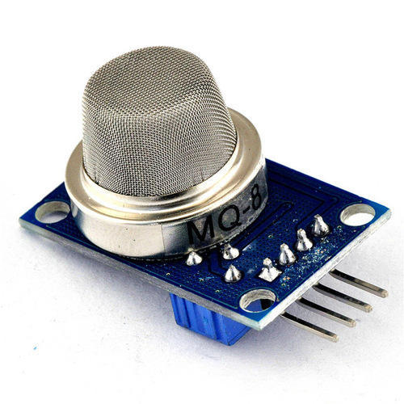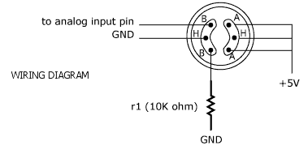

**Fig no.9: GAS SENSOR WIRING DIAGRAM**

GAS SENSOR SPECIFICATIONS:

Power: 2.5V ~ 5.0V

Good sensitivity to harmful gases in wide range.

It has long life and low cost.

Possesses high sensitivity to ammonia, benzene, sulfide gases.

It is a simple drive circuit

A GAS sensor or a GAS Detector is a type of chemical sensor which detects/measures the concentration of gas in its vicinity. Gas sensor interacts with a gas to measure in concentration. They are used in various industries ranging from medicine to aerospace. Various technologies are used to measure Gas concentration such as semiconductors, oxidation, catalytic, infrared, etc. The most common types are as follows

1. Metal Oxide Based GAS Sensor.
2. Capacitance Based GAS Sensor.
3. Acoustic Based GAS Sensor.
4. Calorimetric GAS Sensor.
5. Optical GAS Sensor.
6. Electrochemical GAS Sensor.

Over here we will focus on the most commonly available GAS sensor which is Metal Oxide Gas Sensor or Metal Oxide Semiconductor (MOS) also called as "Chemiresistors". The detection is based upon change of resistance of the sensing material when the Gas comes in contact with the material. These Metal Oxide Gas Sensor are extensively used in industry because of their low cost, flexibility in production; simplicity of their use; large number of detectable gases/possible application fields.

Various gas sensors are available in the market but the most commonly available series is the "MQ Series". Various gasses like, LPG, Carbon Monoxide (CO), Methane, Smoke, Alcohol, etc. can be monitored using these sensors. A good thing about these series is that all are 6 pin sensors with same footprint, same interfacing circuit and are easily available at low cost.

## Applications

#### Process control industries

#### Environmental monitoring

#### Boiler control

#### Fire detection

#### Alcohol breath tests

#### Detection of harmful gases in mines

#### Home safety

#### Grading of agro-products like coffee and spices

## Features

#### High sensitivity

#### Fast response

#### Wide detection range

#### Stable performance and long life

#### Simple drive circuit

#### TEMPERATURE SENSOR:

#### C:\Users\USER\Downloads\lm35-temperature-sensor-500x500.jpgC:\Users\USER\Downloads\index.png

**Fig no.10: TEMPERATRE SENSOR (LM35) PIN DIAGRAM**

TEMPERATRE SENSOR SPECIFICATIONS:

Calibrated Directly in Celsius (Centigrade)

0.5°C Ensured Accuracy (at 25°C)

Rated for Full −55°C to 150°C Range

Suitable for Remote Applications

Low-Cost

Operates From 4 V to 30 V

Less Than 60-µA

Temperature sensors are vital to a variety of everyday products. For example, household ovens, refrigerators, and thermostats all rely on temperature maintenance and control in order to function properly. Temperature control also has applications in chemical engineering. Examples of this include maintaining the temperature of a chemical reactor at the ideal set-point, monitoring the temperature of a possible runaway reaction to ensure the safety of employees, and maintaining the temperature of streams released to the environment to minimize harmful environmental impact.

While temperature is generally sensed by humans as “hot”, “neutral”, or “cold”, chemical engineering requires precise, quantitative measurements of temperature in order to accurately control a process. This is achieved through the use of temperature sensors, and temperature regulators which process the signals they receive from sensors.

From a thermodynamics perspective, temperature changes as a function of the average energy of molecular movement. As heat is added to a system, molecular motion increases and the system experiences an increase in temperature. It is difficult, however, to directly measure the energy of molecular movement, so temperature sensors are generally designed to measure a property which changes in response to temperature. The devices are then calibrated to traditional temperature scales using a standard (i.e. the boiling point of water at known pressure). The following sections discuss the various types of sensors and regulators.

Temperature sensors are devices used to measure the temperature of a medium. There are 2 kinds on temperature sensors: 1) contact sensors and 2) noncontact sensors. However, the 3 main types are thermometers, resistance temperature detectors, and thermocouples. All three of these sensors measure a physical property (i.e. volume of a liquid, current through a wire), which changes as a function of temperature. In addition to the 3 main types of temperature sensors, there are numerous other temperature sensors available for use.

The LM35 is an integrated circuit sensor that can be used to measure temperature with an electrical output proportional to the temperature (in **o**C). The LM35 temperature sensor measure temperature more accurately than using a thermistor. The sensor circuitry is sealed and not subject to oxidation, etc. The LM35 generates higher output voltage than thermocouples and may not require that the output voltage be amplified. It has an output voltage that is proportional to the Celsius temperature. The scale factor of LM35 is 0.1 V/ **o**C. The LM35 draws only 60 micro amps from its supply and possesses a low self-heating capability. The sensor self-heating causes less than 0.1 **o**C temperature rise in still air.

**LIGHT SENSOR:**

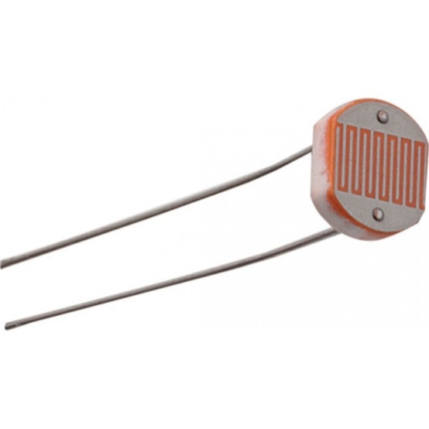

**Fig no.11: LIGHT SENSOR (LDR)**

LIGHT SENSOR SPECIFICATIONS

|  |  |
| --- | --- |
| Max power dissipation | 200mW |
| Max voltage @ 0 lux | 200V |
| Peak wavelength | 600nm |
| Min. resistance @ 10lux | 1.8kΩ |
| Max. resistance @ 10lux | 4.5kΩ |
| Typ. resistance @ 100lux | 0.7kΩ |
| Dark resistance after 1 sec | 0.03MΩ |
| Dark resistance after 5 sec | 0.25MΩ |

A **photo resistor** (or **light-dependent resistor**, **LDR**, or **photo-conductive cell**) is a light-controlled variable [resistor](https://en.wikipedia.org/wiki/Resistor). The [resistance](https://en.wikipedia.org/wiki/Electrical_resistance) of a photo resistor decreases with increasing incident light intensity; in other words, it exhibits [photoconductivity](https://en.wikipedia.org/wiki/Photoconductivity). A photo resistor can be applied in light-sensitive detector circuits, and light-activated and dark-activated switching circuits.

A photo resistor is made of a high resistance [semiconductor](https://en.wikipedia.org/wiki/Semiconductor). In the dark, a photo resistor can have a resistance as high as several megohms (MΩ), while in the light, a photoresistor can have a resistance as low as a few hundred ohms. If incident light on a photoresistor exceeds a certain [frequency](https://en.wikipedia.org/wiki/Frequency), [photons](https://en.wikipedia.org/wiki/Photon) absorbed by the semiconductor give bound [electrons](https://en.wikipedia.org/wiki/Electron) enough energy to jump into the [conduction band](https://en.wikipedia.org/wiki/Conduction_band). The resulting free electrons (and their [hole](https://en.wikipedia.org/wiki/Electron_hole) partners) conduct electricity, thereby lowering [resistance](https://en.wikipedia.org/wiki/Electrical_resistance). The resistance range and sensitivity of a photoresistor can substantially differ among dissimilar devices. Moreover, unique photo resistors may react substantially differently to photons within certain wavelength bands.

A photoelectric device can be either intrinsic or extrinsic. An intrinsic semiconductor has its own [charge carriers](https://en.wikipedia.org/wiki/Charge_carrier) and is not an efficient semiconductor, for example, silicon. In intrinsic devices the only available electrons are in the [valence band](https://en.wikipedia.org/wiki/Valence_band), and hence the photon must have enough energy to excite the electron across the entire [band gap](https://en.wikipedia.org/wiki/Bandgap). Extrinsic devices have impurities, also called [dopants](https://en.wikipedia.org/wiki/Dopants), and added whose ground state energy is closer to the conduction band; since the electrons do not have as far to jump, lower energy photons (that is, longer wavelengths and lower frequencies) are sufficient to trigger the device. If a sample of silicon has some of its atoms replaced by phosphorus atoms (impurities), there will be extra electrons available for conduction. This is an example of an extrinsic semiconductor.

Photoresistors come in many types. Inexpensive [cadmium sulfide](https://en.wikipedia.org/wiki/Cadmium_sulfide) cells can be found in many consumer items such as camera light meters, clock radios, [alarm devices](https://en.wikipedia.org/wiki/Alarm_devices) (as the detector for a light beam), [nightlights](https://en.wikipedia.org/wiki/Nightlight), outdoor clocks, solar street lamps and solar road studs, etc.

Photoresistors can be placed in streetlights to control when the light is on. Ambient light falling on the photoresistor causes the streetlight to turn off. Thus energy is saved by ensuring the light is only on during hours of darkness.

They are also used in some [dynamic compressors](https://en.wikipedia.org/wiki/Dynamic_range_compression) together with a small [incandescent](https://en.wikipedia.org/wiki/Incandescent_lamp) or [neon](https://en.wikipedia.org/wiki/Neon)[lamp](https://en.wikipedia.org/wiki/Neon_lamp), or [light-emitting diode](https://en.wikipedia.org/wiki/Light-emitting_diode) to control gain reduction. A common usage of this application can be found in many [guitar amplifiers](https://en.wikipedia.org/wiki/Guitar_amplifiers) that incorporate an onboard [tremolo](https://en.wikipedia.org/wiki/Tremolo_(electronic_effect)) effect, as the oscillating light patterns control the level of signal running through the amp circuit.

**RFID READER AND CARD:**

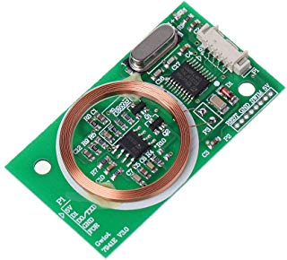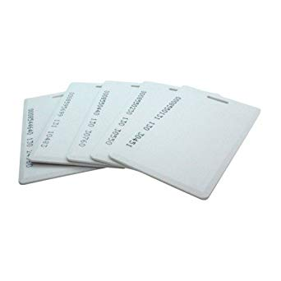

**Fig no.12: RFID READER AND CARD**

**Radio-frequency identification** (**RFID**) uses [electromagnetic fields](https://en.wikipedia.org/wiki/Electromagnetic_field) to automatically identify and track tags attached to objects. The tags contain electronically stored information. Passive tags collect energy from a nearby RFID reader's interrogating [radio waves](https://en.wikipedia.org/wiki/Radio_wave). Active tags have a local power source (such as a battery) and may operate hundreds of meters from the RFID reader. Unlike a [barcode](https://en.wikipedia.org/wiki/Barcode), the tag need not be within the line of sight of the reader, so it may be embedded in the tracked object. RFID is one method of [automatic identification and data capture](https://en.wikipedia.org/wiki/Automatic_identification_and_data_capture) (AIDC).

Since RFID tags can be attached to cash, clothing, and possessions, or implanted in animals and people, the possibility of reading personally-linked information without consent has raised serious privacy concerns.These concerns resulted in standard specifications development addressing privacy and security issues. [ISO/IEC 18000](https://en.wikipedia.org/wiki/ISO/IEC_18000) and ISO/IEC 29167 use on-chip [cryptography](https://en.wikipedia.org/wiki/Cryptography) methods for intractability, tag and reader [authentication](https://en.wikipedia.org/wiki/Authentication), and over-the-air privacy. [ISO/IEC 20248](https://en.wikipedia.org/wiki/ISO/IEC_20248) specifies a [digital signature](https://en.wikipedia.org/wiki/Digital_signature) data structure for RFID and [barcodes](https://en.wikipedia.org/wiki/Barcodes) providing data, source and read method authenticity. This work is done within [ISO/IEC JTC 1/SC 31 Automatic identification and data capture techniques](https://en.wikipedia.org/wiki/ISO/IEC_JTC_1/SC_31_Automatic_identification_and_data_capture_techniques). Tags can also be used in shops to expedite checkout, and to prevent theft by customers and employees.

**MOTION SENSOR:**

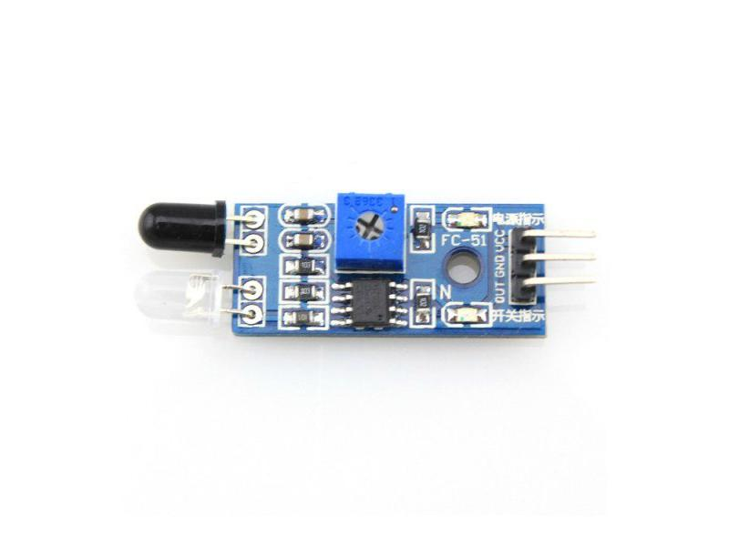

**Fig no.13: MOTION SENSOR**

MOTION SENSOR SPECIFICATIONS:

|  |  |
| --- | --- |
| Range | 0.5cm 5 cm |
| Color | blue |
| Distance Measuring Range | up to30cm adjustable with pot |
| Detecting Angle | 35 deg |
| Weight G | Approx. 10g |
| Operating Temperature | 0C to 60C 10 |
| Type | IR Obstacle sensor |
| Voltage | 5v |

A **passive infrared sensor** (**PIR sensor**) is an electronic [sensor](https://en.wikipedia.org/wiki/Sensor) that measures [infrared](https://en.wikipedia.org/wiki/Infrared) (IR) light radiating from objects in its field of view. They are most often used in PIR-based [motion detectors](https://en.wikipedia.org/wiki/Motion_detector). PIR sensors are commonly used in security alarms and automatic lighting applications. PIR sensors detect general movement, but do not give information on who or what moved. For that purpose, an [active IR sensor](https://en.wikipedia.org/wiki/Active_IR_sensor) is required.

PIR sensors are commonly called simply "PIR", or sometimes "PID", for "passive infrared detector". The term *passive* refers to the fact that PIR devices do not radiate energy for detection purposes. They work entirely by detecting [infrared radiation](https://en.wikipedia.org/wiki/Infrared_radiation) (radiant heat) emitted by or reflected from objects.

A PIR sensor can detect changes in the amount of infrared radiation impinging upon it, which varies depending on the temperature and surface characteristics of the objects in front of the sensor. When an object, such as a person, passes in front of the background, such as a wall, the temperature at that point in the sensor's field of view will rise from [room temperature](https://en.wikipedia.org/wiki/Room_temperature) to [body temperature](https://en.wikipedia.org/wiki/Body_temperature), and then back again. The sensor converts the resulting change in the incoming infrared radiation into a change in the output voltage, and this triggers the detection. Objects of similar temperature but different surface characteristics may also have a different infrared emission pattern, and thus moving them with respect to the background may trigger the detector as well.

PIRs come in many configurations for a wide variety of applications. The most common models have numerous [Fresnel lenses](https://en.wikipedia.org/wiki/Fresnel_lens) or mirror segments, an effective range of about 10 meters (30 feet), and a field of view less than 180°. Models with wider fields of view, including 360°, are available, typically designed to mount on a ceiling. Some larger PIRs are made with single segment mirrors and can sense changes in infrared energy over 30 meters (100 feet) from the PIR. There are also PIRs designed with reversible orientation mirrors which allow either broad coverage (110° wide) or very narrow "curtain" coverage or with individually selectable segments to "shape" the coverage.

**WIFI-MODULE**

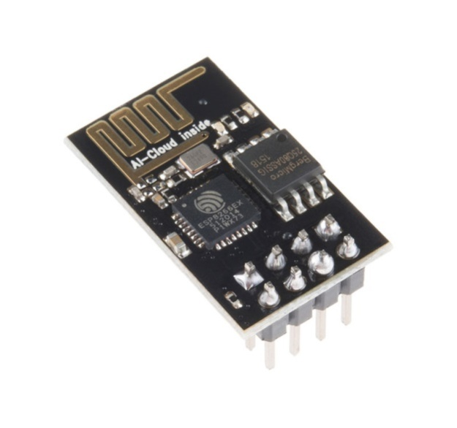

**Fig no.14: WIFI-MODULE**

ESP8266 is Wi-Fi enabled system on chip (SoC) module developed by Espressif system. It is mostly used for development of IoT (Internet of Things) embedded applications.

ESP8266 comes with capabilities of

* 2.4 GHz Wi-Fi (802.11 b/g/n, supporting WPA/WPA2),
* general-purpose input/output (16 GPIO),
* Inter-Integrated Circuit (I²C) serial communication protocol,
* analog-to-digital conversion (10-bit ADC)
* Serial Peripheral Interface (SPI) serial communication protocol,
* I²S (Inter-IC Sound) interfaces with DMA(Direct Memory Access) (sharing pins with GPIO),
* UART (on dedicated pins, plus a transmit-only UART can be enabled on GPIO2), and
* pulse-width modulation (PWM).

It employs a 32-bit RISC CPU. It has a 64 KB boot ROM, 64 KB instruction RAM and 96 KB data RAM. External flash memory can be accessed through SPI.ESP8266 module is low cost standalone wireless transceiver that can be used for end-point IoT developments.To communicate with the ESP8266 module, microcontroller needs to use set of AT commands. Microcontroller communicates with ESP8266-01 module using UART having specified Baud rate.

**DC MOTOR:**

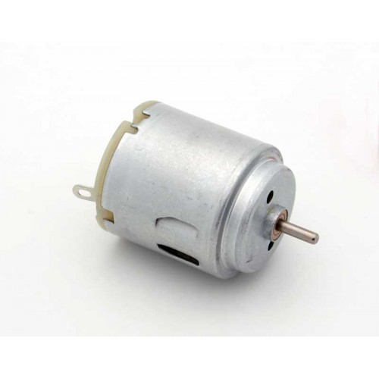[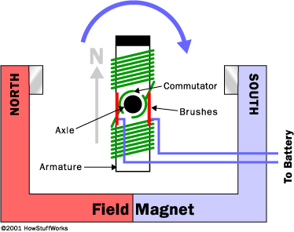](http://auto.howstuffworks.com/enlarge-image.htm?terms=motor&page=0)

**Fig no.15: Principle of working of motor**

Electric motors are everywhere! In your house, almost every mechanical movement that you see around you is caused by an AC (alternating current) or DC (direct current) electric motor. Let's start by looking at the overall plan of a simple two-pole DC **electric motor**. A simple motor has six parts, as shown in the diagram below:

* **Armature or rotor**
* **Commutator**
* **Brushes**
* **Axle**
* **Field magnet**
* **DC power supply** of some sort

An el­ectric motor is all about magnets and magnetism: A motor uses **magnets** to create motion. If you have ever played with magnets you know about the fundamental law of all magnets: Opposites attract and likes repel. So if you have two bar magnets with their ends marked "north" and "south," then the north end of one magnet will attract the south end of the other. On the other hand, the north end of one magnet will repel the north end of the other (and similarly, south will repel south). Inside an electric motor, these attracting and repelling forces create **rotational motion**. ­

In the above diagram, you can see two magnets in the motor: The armature (or rotor) is an electromagnet, while the field magnet is a permanent magnet (the field magnet could be an electromagnet as well, but in most small motors it isn't in order to save power).

To understand how an electric motor works, the key is to understand how the electromagnet works. (See How Electromagnets Work for complete details.)

An electromagnet is the basis of an electric motor. You can understand how things work in the motor by imagining the following scenario. Say that you created a simple electromagnet by wrapping 100 loops of wire around a nail and connecting it to a battery. The nail would become a magnet and have a north and south pole while the battery is connected.

**H-BRIDGE:**

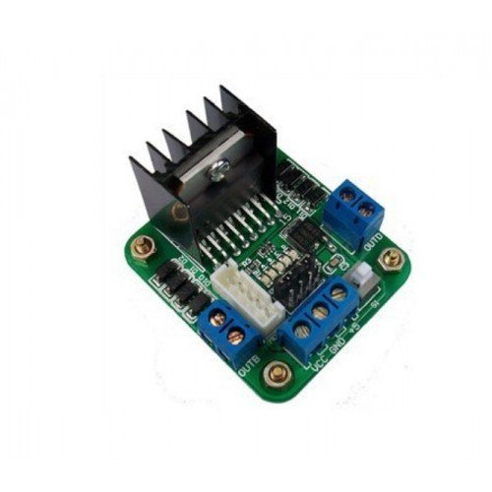

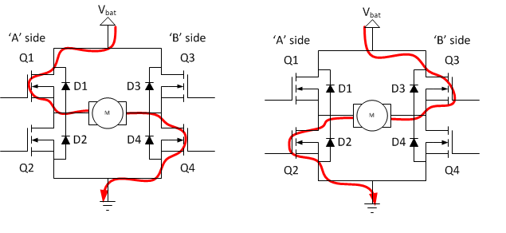

**Fig no.16: Connections for clockwise and anti-clockwise rotation of motor**

An **H bridge** is an [electronic circuit](https://en.wikipedia.org/wiki/Electronic_circuit) that switches the polarity of a voltage applied to a load. These circuits are often used in [robotics](https://en.wikipedia.org/wiki/Robotics) and other applications to allow DC motors to run forwards or backwards.

Most DC-to-AC converters ([power inverters](https://en.wikipedia.org/wiki/Power_inverter)), most [AC/AC converters](https://en.wikipedia.org/wiki/AC/AC_converter), the DC-to-DC [push–pull converter](https://en.wikipedia.org/wiki/Push%E2%80%93pull_converter), most [motor controllers](https://en.wikipedia.org/wiki/Motor_controller), and many other kinds of [power electronics](https://en.wikipedia.org/wiki/Power_electronics) use H bridges. In particular, a [bipolar stepper motor](https://en.wikipedia.org/wiki/Stepper_motor#Bipolar_motor) is almost invariably driven by a motor controller containing Two H Bridges.

H bridges are available as [integrated circuits](https://en.wikipedia.org/wiki/Integrated_circuits), or can be built from [discrete components](https://en.wikipedia.org/wiki/Discrete_components).

The term *H* Bridge is derived from the typical graphical representation of such a circuit. An H bridge is built with four switches (solid-state or mechanical). When the switches S1 and S4 (according to the first figure) are closed (and S2 and S3 are open) a positive voltage will be applied across the motor. By opening S1 and S4 switches and closing S2 and S3 switches, this voltage is reversed, allowing reverse operation of the motor.

Using the nomenclature above, the switches S1 and S2 should never be closed at the same time, as this would cause a short circuit on the input voltage source. The same applies to the switches S3 and S4. This condition is known as shoot-through

The H-bridge arrangement is generally used to reverse the polarity/direction of the motor, but can also be used to 'brake' the motor, where the motor comes to a sudden stop, as the motor's terminals are shorted, or to let the motor 'free run' to a stop, as the motor is effectively disconnected from the circuit. The following table summarises operation.

**RELAY:**

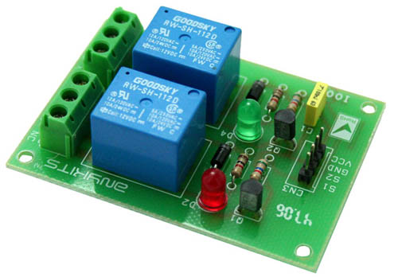

**Fig no.17: RELAY**

2 channel Relay driver project can be controlled by feeding 2-12V trigger voltage, Very useful project for application like Micro-Controller based projects, Remote controller, Lamp on Off, and any circuits which required isolated high current and high voltage switching by applying any TTL or CMOS level voltage. Two LED works as operation indicator while in , 3 pins screw terminals to connect load and provides  both normally open and normally closed switching.

* Input: 12 VDC @ 84 mA
* Output: Two SPDT relay
* Relay specification: 5 A @ 230 VAC
* Trigger level : 2 to 12 VDC
* Header connector for connecting power and trigger voltage
* LED on each channel indicates relay status
* Power Battery Terminal (PBT) for easy relay output connection
* Four mounting holes of 3.2 mm each
* PCB dimensions 49 mm x 68 mm

**FAN:**

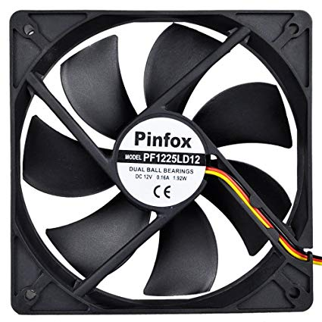

**Fig no.18: FAN**

|  |  |
| --- | --- |
| Max air flow | 49.7CFM |
| Maxim noise | 44dBA |
| Operation Temperature | -10~75 degree C |
| Rated speed | 4000 - 5000RPM |
| Rated voltage | 12 V |
| Relative humidity | 65%+/-20% |

A **fan** is a powered [machine](https://en.wikipedia.org/wiki/Machine) used to create flow within a [fluid](https://en.wikipedia.org/wiki/Fluid), typically a [gas](https://en.wikipedia.org/wiki/Gas) such as [air](https://en.wikipedia.org/wiki/Air). A fan consists of a rotating arrangement of vanes or blades which act on the air. The rotating assembly of blades and hub is known as an impeller, a rotor, or a runner. Usually, it is contained within some form of housing or case. This may direct the airflow or increase safety by preventing objects from contacting the fan blades. Most fans are powered by [electric](https://en.wikipedia.org/wiki/Electricity) motors.

**CHAPTER 7**

**SOFTWARE USED:**

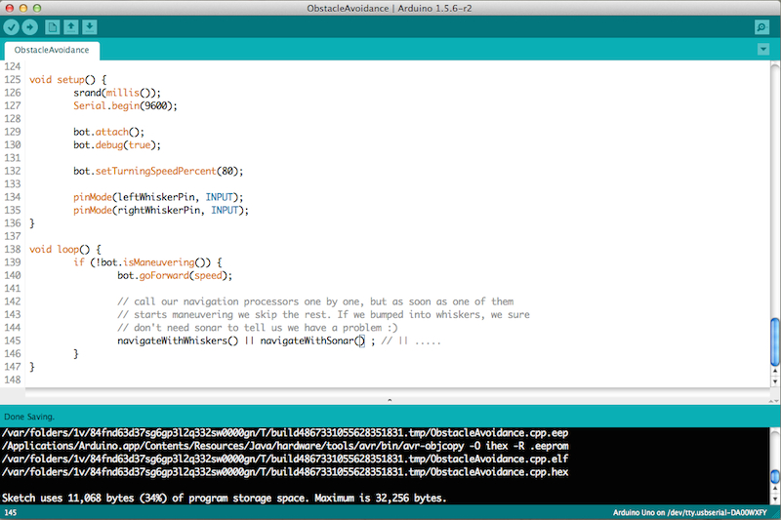

**Fig no.19: ARDUINO COMPILER**

A number of things have to happen for your Arduino code to get onto the Arduino board. First, the Arduino environment performs some minor pre-processing to turn your sketch into a C++ program. It then gets passed to a compiler (avr-gcc), which turns the human readable code into machine readable instructions (or object files). Then your code gets combined with (linked against), the standard Arduino libraries that provide basic functions like digital Write() or Serial. Print(). The result is a single Intel hex file, which contains the specific bytes that need to be written to the program memory of the chip on the Arduino board. This file is then uploaded to the board: transmitted over the USB or serial connection via the boot loader already on the chip or with external programming hardware.

**TCP/IP APP:**

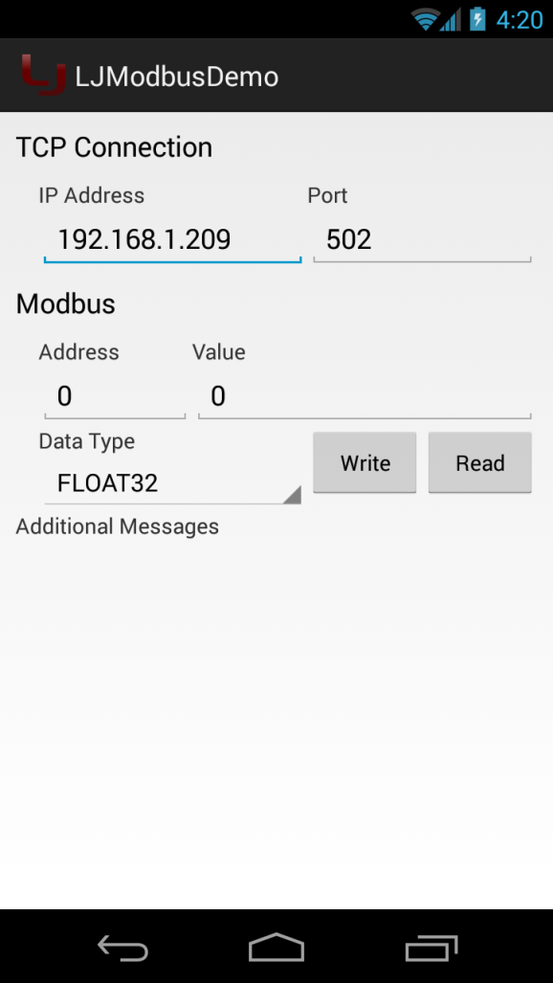

**Fig no.20: TCP/IP APP**

TC/I*P* applications operate at the application or process layer of the TCP/I*P* hierarchy *as* discussed in the preceding sections. TCP/IPprotocol splits an application into server and client components. The server component is a service provider that controls commonly shared resources pertaining to a particular application on the network. The server normally runs on a remote, high-powered, [computer](http://ecomputernotes.com/fundamental/introduction-to-computer/what-is-computer) to which only authorized users have access. The client component is the service user. That piece of software engages with the server in a sequence of request-response data grams fulfilling certain user-specified demands or requirements.

**ARDUINO PROGRAM IMPLEMENTED:**

#include <SoftwareSerial.h>

SoftwareSerial mySerial(6, 7); // RX, TX

#include <string.h>

#include <stdio.h>

#include <stdlib.h>

const int IN1=10;

const int IN2=11;

const int GAS_PIN = A5;

const int led1=3;

const int led2=A2;

int ldrpin=A3;

//const int current=

const int buzzer=A4;

//int ldrstatus=0;

int GAS_VALUE;

//const int buzzerPin = 2;

const int MotorPump = 8;

const int FAN = 5;

float sample,data,exceed;

int temp1;

const int irsensor=4;

void rfid(void);

char ch=0,temp[20];

String str="";

const int fireSensorPin = 12;

const int tempSensor=A0;

int max_temp = 60;

int ldrstatus=0;

void setup() {

// put your setup code here, to run once:

Serial.begin(115200);

mySerial.begin(9600);

pinMode(IN1,OUTPUT);

pinMode(IN2

,OUTPUT);

pinMode(buzzer,OUTPUT);

pinMode(MotorPump,OUTPUT);

pinMode(FAN,OUTPUT);

pinMode(GAS_PIN,INPUT);

pinMode(ldrpin,INPUT);

pinMode(led1,OUTPUT);

pinMode(led2,OUTPUT);

pinMode(irsensor,INPUT);

pinMode(fireSensorPin, INPUT);

WIFI();

Serial.write("AT+CIPSEND=0,31\r\n"); // MULTIPLE MODE SELECTION

delay(50);

Serial.write("IOT BASED INDUSTRIAL PRODUCTION");

delay(50);

Serial.write("\n\r\r"); // MULTIPLE MODE SELECTION

delay(1000);

}

void loop()

{

RFID_MONITOR();

TEMP_MONITOR();

Fire_Monitor();

GAS_MONITOR();

ldr_check();

delay(1000);

}

void TEMP_MONITOR()

{

int TEMP_VALUE= analogRead(tempSensor);

// Serial.println(TEMP_VALUE);

if(TEMP_VALUE>68)

{

digitalWrite(FAN, HIGH);

digitalWrite(buzzer, HIGH);

Serial.write("AT+CIPSEND=0,17\r\n"); // MULTIPLE MODE SELECTION

delay(50);

Serial.write("Temperature Alert");

delay(50);

Serial.write("\n\r\r"); // MULTIPLE MODE SELECTION

delay(1000);

digitalWrite(buzzer, LOW);

digitalWrite(FAN, LOW);

//

}

}

void ldr_check()

{

int ldr_state = analogRead(ldrpin);

// Serial.print("ldr_state:");

// Serial.println(ldr_state);

if(ldr_state<20)

{

digitalWrite(led1,HIGH);

digitalWrite(led2,HIGH);

}

else

digitalWrite(led1,LOW);

digitalWrite(led2,LOW);

}

void Fire_Monitor (void)

{

if(digitalRead(fireSensorPin) == LOW)

{

digitalWrite(buzzer, HIGH);

digitalWrite(MotorPump, HIGH);

digitalWrite(FAN, HIGH);

Serial.write("AT+CIPSEND=0,18\r\n"); // MULTIPLE MODE SELECTION

delay(50);

Serial.write("FIRE ALERT MESSAGE");

delay(50);

Serial.write("\n\r\r"); // MULTIPLE MODE SELECTION

delay(2000);

digitalWrite(buzzer, LOW);

digitalWrite(MotorPump, LOW);

// Serial.write("AT+CIPSEND=0,13\r\n"); // MULTIPLE MODE SELECTION

// delay(50);

// Serial.write("Fire Detected");

// delay(50);

// Serial.write("\n\r\r");

// delay(1000);

digitalWrite(buzzer, LOW);

digitalWrite(FAN, LOW);

digitalWrite(MotorPump, LOW);

digitalWrite(IN1,HIGH);

digitalWrite(IN2,LOW);

delay(300);

digitalWrite(IN1,LOW);

digitalWrite(IN2,LOW);

delay(3000);

digitalWrite(IN1,LOW);

digitalWrite(IN2,HIGH);

delay(300);

digitalWrite(IN1,LOW);

digitalWrite(IN2,LOW);

}

}

void RFID_MONITOR(void)

{

if(mySerial.available()>0) //RFID

{

//Serial.print(ch=Serial.read());

str=mySerial.readString();

//delay(1000);

//Serial.print(str);

if(str!="")

{//Serial.print(str);

str.toCharArray(temp, 13);

temp[11]='\0';

Serial.write("AT+CIPSEND=0,13\r\n"); // MULTIPLE MODE SELECTION

delay(50);

Serial.write(temp);

delay(50);

Serial.write("HUMAN DETECTED");

delay(50);

Serial.write("\n\r\r"); // MULTIPLE MODE SELECTION

delay(1000);

Serial.print(temp);

Serial.println("rfid loop");

if(!strcmp(temp,"$0001304985"))

{

Serial.println("rfid matched");

Serial.write("rfid matched");

delay(50);

digitalWrite(IN1,HIGH);

digitalWrite(IN2,LOW);

delay(300);

digitalWrite(IN1,LOW);

digitalWrite(IN2,LOW);

while(digitalRead(irsensor)== LOW);

digitalWrite(IN1,LOW);

digitalWrite(IN2,HIGH);

delay(300);

digitalWrite(IN1,LOW);

digitalWrite(IN2,LOW);

}

//Serial.print("comp");

else

{

Serial.println("rfid mismatched");

Serial.write("rfid mismatched");

delay(50);

}

//Serial.print("not comp");

str="";}

//rfid();

}

}

void GAS_MONITOR(void)

{

GAS_VALUE= digitalRead(GAS_PIN);

// Serial.print(GAS_VALUE);

// Serial.write("AT+CIPSEND=0,17\r\n"); // MULTIPLE MODE SELECTION

// delay(50);

// Serial.write("SMOKE");

// delay(50);

//

// Serial.print("SMOKE:");

// Serial.println(GAS_VALUE);

if(GAS_VALUE == LOW)

{

digitalWrite(buzzer, HIGH);

// digitalWrite(MotorPump, HIGH);

digitalWrite(FAN, HIGH);

Serial.write("AT+CIPSEND=0,14\r\n"); // MULTIPLE MODE SELECTION

delay(50);

Serial.write("SMOKE DETECTED");

delay(50);

Serial.write("\n\r\r"); // MULTIPLE MODE SELECTION

delay(1000);

digitalWrite(buzzer, LOW);

// digitalWrite(buzzer, LOW);

digitalWrite(FAN, LOW);

// digitalWrite(MotorPump, LOW);

digitalWrite(IN1,HIGH);

digitalWrite(IN2,LOW);

delay(300);

digitalWrite(IN1,LOW);

digitalWrite(IN2,LOW);

delay(3000);

digitalWrite(IN1,LOW);

digitalWrite(IN2,HIGH);

delay(300);

digitalWrite(IN1,LOW);

digitalWrite(IN2,LOW);

delay(2000);

}

}

void MOTOR_FWD()

{

digitalWrite(IN1,HIGH);

//delay(10);

digitalWrite(IN2,LOW);

delay(100);

Serial.println("GATE IS OPEN");

Serial.write("GATE IS OPEN");

}

void MOTOR_BWD()

{

digitalWrite(IN1,LOW);

digitalWrite(IN2,LOW);

delay(100);

Serial.println("GATE IS CLOSING");

Serial.write("GATE IS CLOSING");

// lcd.print("GATE IS CLOSING");

// lcd.clear();

}

void MOTOR_STP()

{

digitalWrite(IN1,LOW);

digitalWrite(IN2,LOW);

Serial.println("GATE IS CLOSED");

Serial.write("GATE IS CLOSED");

}

void MOTOR_Condition()

{

MOTOR_BWD();

delay(2000);

MOTOR_STP();

delay(10);

}

void Fan_Light()

{

digitalWrite(FAN,HIGH);

delay(10000);

digitalWrite(FAN,LOW);

digitalWrite(MotorPump,HIGH);

delay(1000);

digitalWrite(MotorPump,LOW);

Serial.println("PUMP is ON");

Serial.write("PUMP IS ON");

Serial.println("Exhaust fan is ON");

Serial.write("EXHAUST FAN IS ON");

Serial.write("PUMP IS ON");

MOTOR_FWD();

delay(1000);

Serial.println("GATE IS OPEN");

Serial.write("GATE IS OPEN");

}

void IR1 (void)

{

if(digitalRead(irsensor)== LOW)

{

Serial.write("NO HUMAN DETECTED");

Serial.println("No HUMAN DETECTED");

MOTOR_Condition();

}

else

{

Serial.println(" HUMAN DETECTED");

Serial.write("HUMAN DETECTED");

MOTOR_FWD();

digitalWrite(buzzer,HIGH);

delay(1000);

digitalWrite(buzzer,LOW);

}

}

void WIFI(void)

{

String BUFF, buff_1;

char ch;

Serial.print('A');

delay(10);

Serial.print('T');

delay(10);

Serial.print('E');

delay(10);

Serial.print('0');

delay(10);

Serial.print("\r\n");

Serial.print("1");

Serial.print(Serial.readString());

delay(50);

Serial.write("AT\r\n");

Serial.print("2");

Serial.print(Serial.readString());

delay(50);

Serial.write("AT+CWMODE=2\r\n");

Serial.print("3");

Serial.print(Serial.readString());

delay(50);

Serial.write("AT+CIPMUX=1\r\n");

Serial.print("8");

Serial.print(Serial.readString());

delay(50);

Serial.write("AT+CIPSERVER=1,80\r\n");

Serial.print("9");

Serial.print(Serial.readString());

delay(50);

Serial.write("AT+CIFSR\r\n");

Serial.print("10");

Serial.print(Serial.readString());

delay(50);

}

// void GAS_weight()

// {

// scale.set_scale(calibration_factor); //Adjust to this calibration factor

// Serial.print("Reading: ");

// Serial.print(scale.get_units(), 1);

// Serial.print(" lbs"); //Change this to kg and re-adjust the calibration factor if you follow SI units like a sane person

// Serial.print(" calibration_factor: ");

// Serial.print(calibration_factor);

// Serial.println();

// if(Serial.available())

// {

// char temp = Serial.read();

// if(temp == '+' || temp == 'a')

// calibration_factor += 10;

// else if(temp == '-' || temp == 'z')

// calibration_factor -= 10;

// if(temp>3.0)

// {

// lcd.clear();

// lcd.setCursor(0, 0);

// lcd.print("GAS=");

// lcd.print(temp);

//

// if(data<100)

// {

// lcd.clear();

// lcd.setCursor(0, 0);

// lcd.print("CYLINDER IS");

// lcd.setCursor(0, 1);

// lcd.print("LOW");

// // intGsm(" ","CYLINDER IS LOW");

//

// lcd.clear();

// lcd.setCursor(0, 0);

// lcd.print("BOOKING GAS");

// // intGsm(" ","CUSTOMSER ID");

// lcd.clear();

// lcd.setCursor(0, 0);

// lcd.print("GAS BOOKED");

// delay(2000);

// }

// }

// else

// {

// lcd.clear();

// lcd.setCursor(0, 0);

// lcd.print("GAS=0.0");

// lcd.print(temp);

// }

//

// delay(500);

// }

// }

// void SendSms( char *num1, char * str1 )

//{

// Serial.println("DOOR I");

// char buff[10],i=0;

// Serial.write('A');

// delay(100);

// Serial.write('T');

// delay(100);

// Serial.write('E');

// delay(100);

// Serial.write('0');

// delay(100);

// Serial.write('\r');

//

// //*****************************************

// Serial.write("AT+CMGF=1\r"); //Initialize GSM For mobile

// delay(2000);

// Serial.write("AT+CMGS=\"");

// delay(2000);

// Serial.write(num1);

// delay(2000);

// Serial.write("\"\r");

// Serial.write(str1);

// delay(2000);

// Serial.write(26);

// delay(2000);

// Serial.print("sms sent");

//

//}

**CHAPTER 8**

**APPLICATIONS:**

**REMOTE MONITORING AND ASSISTANCE:**

Asmart manufacturing should also establish remote and monitoring assistance system, solution that actively contribute to improving the performance in industrial plant. Companies can supervise, check and set the variables of the machine or the entire production process.

**MACHINE CONTROL AND PRODUCTION:**

Machine monitoring and industrial production process plays a key role in the concept of smart factory. The collection and analysis of data has the purpose of making the industrial activity faster, with high level of quality of goods at a lower price.

**PREVENTIVE MAINTENANCE:**

Preventive maintenance is one of the fundamental for maximize the effectiveness maintenance activities of companies, reducing breakdown and setup costs. The management of Big Data and the subsequent analysis of data collected, allowing monitoring the machinery identifying in time the incipient failure.

**ENERGY EFFICIENCY:**

For smart factory, where digitalization has turned the traditional concept of industry, energy systems should be equally sustainable, efficient and cutting edge. The monitoring of energy, water and gas by dedicated applications, allows analyzing each phase of the production process and planning potential action to improve energy efficiency useful for optimizing costs and business energy consumption.

**ENVIRONMENTAL MONITORING:**

Smart factory is closely linked to the concept of green economy, an economic model developed that takes care of energy efficiency and potential environmental damage caused by unsustainable production. The applications, for environmental monitoring, store and analyze a large volume of data for water, boiler emission, solar energy and fluorinated gases according to national and international laws.

**CHAPTER 9**

**ADVANTAGES OF INDUSTRIAL AUTOMATION:**

* To increase labor productivity
* To reduce labor cost
* To mitigate the effects of labor shortages
* To reduce or remove routine manual and clerical tasks
* To improve worker safety
* To improve product quality
* To reduce manufacturing lead time
* To accomplish what cannot be done manually
* To avoid the high cost of not automating

**DISADVANTAGES OF INDUSTRIAL AUTOMATION:**

* Unemployment: Unemployment rate increases due to machines replacing humans and putting those humans out of their jobs.
* Technical Limitation: Current technology is unable to automate all the desired tasks.
* Security Threats/Vulnerability: An automated system may have limited level of intelligence; hence it is most likely susceptible to commit error.
* Unpredictable development costs: The research and development cost of automating a process may exceed the cost saved by the automation itself.
* High initial cost: The automation of a new product or plant requires a huge initial investment in comparison with the unit cost of the product, although the cost of automation is spread in many product batches.

**CHAPTER 10**

**RESULTS:**

All the sensor inputs and sensor outputs are coded in the Arduino Uno Microcontroller Chip and the data are dumped in it. Whenever any sensor is functioning, an alert is sent to the TCP/UDP TEST TOOL Application in our mobiles through the Wi-Fi Signal present in our Model Design. The Wi-Fi range of our module is 10 meters. Though the errors occurred in the factory is sensed and rectified by automation, an immediate alert is sent in our mobile application so as to know the mishaps happening in the factory and prevent such mishaps in the future. The various sensors used, their input and outputs, and what results we incur from them are briefly listed below.

* **RFID Sensor along with Motion Sensor**
* **Input -** We swipe an RFID card on the RFID reader.
* **Output -** As soon as the sensor identifies the card number, the gate is opened and the person gets inside. After he gets inside, the motion sensor senses his/her presence and automatically closes the gate. We get an alert in the mobile application of the card number as who entered the premises.
* **Result Incurred -** Workers who have access in the factory has their card numbers stored in the database. Outsiders cannot enter easily without authorization of the card or until their card number is stored in the database. Hence this system can be used as a safety system.
* **Fire Sensor**
* **Input -** We use a lighter near the fire sensor as the input.
* **Output -** As soon as the sensor identifies the fire, immediately the buzzer alerts, the fan and the water pumps starts operating in order to extinguish the fire and the gate opens so that the workers can leave the factory premises. We get an alert in the mobile application as “fire alert”.
* **Result Incurred –** This system can be used as an Automatic Fire Alert System.
* **Gas Sensor**
* **Input -** We use smoke emanating from the incense stick near the gas sensor as the input.
* **Output -** As soon as the sensor identifies the smoke, immediately the buzzer alerts, and the fan starts operating in order to extinguish the smoke getting around and the gate opens so that the workers can leave the factory premises. We get an alert in the mobile application as “smoke detected”.
* **Result Incurred -** This system can be used as Automatic Smoke Alert System.
* **Temperature Sensor**
* **Input -** We use the heat emanating from the incense stick near the temperature sensor as the input.
* **Output -** As soon as the sensor identifies high temperature, the buzzer alerts and the fan starts operating in order to cool down the surrounding temperature. We get an alert in the mobile application as “temperature alert”.
* **Result Incurred -** This system is mostly used in high temperature areas like boilers and power plants where the temperature is usually high. It is also used in normal temperature areas so that any changes in the temperature will alert the person present in the premises and they may avoid burns or other mishaps.
* **Light Sensor**
* **Input** - We cover the light sensor with our hands so that no light falls on the light sensor.
* **Output** - As soon as the sensor identifies the dark surroundings, the LED present in the module lights up.
* **Result Incurred** - This system is used in factories where lights are forever required.

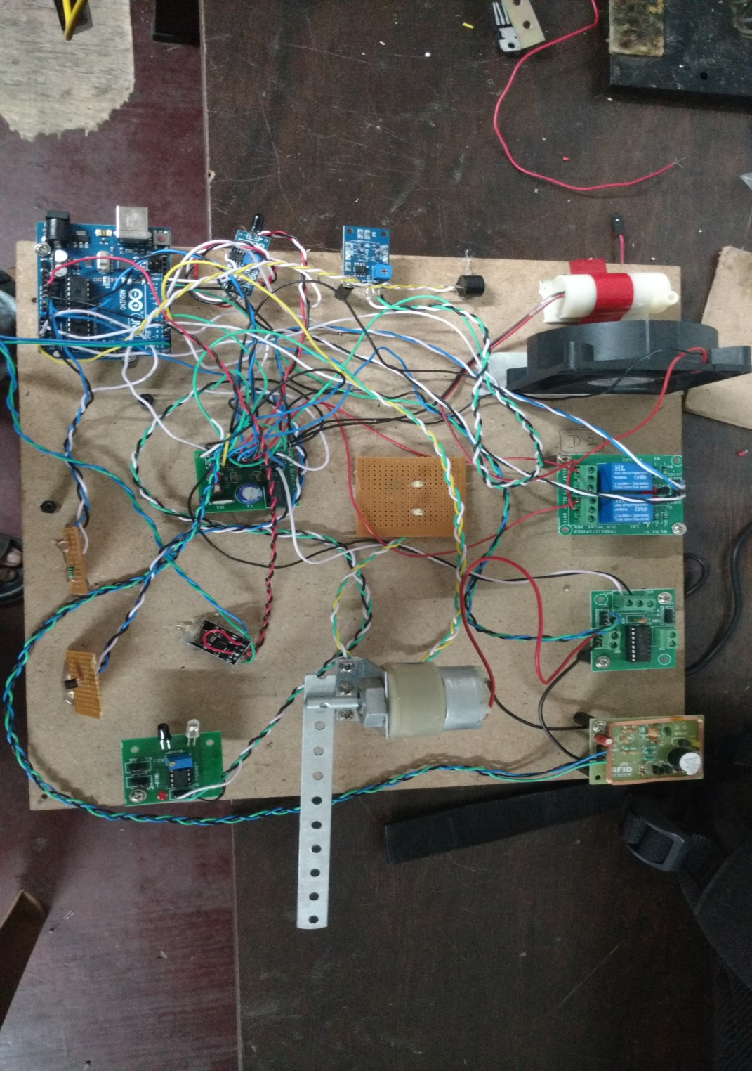

FINAL PRESENTATION OF PROJECT

**CHAPTER 11**

**CONCLUSION:**

* By implementing this system we can access the live data and also control the device interfaced with our system.
* It helps for monitoring industrial appliances and to inform the responsible person to take appropriate measures.
* To serve as an efficient backbone for achieving a network of sensors and actuators this can help for improving the performance of the day to day activities of the industry.
* Gas leakages in households and industries cause risk to life and property. A huge loss has to be incurred for the accident occurred by such leakages. A solution to such a problem is to set up a monitoring system which keeps on monitoring the leakage of any kind of flammable gases and protects the consumer from such accidents.
* The present paper provides a solution to prevent such accidents by monitoring the system but also communicating the same with IoT network to switch off the gas supplies and the main power in case of a leakage.
* In addition to this, it activates an alarm as well as sends a message to the authorities.
* A further advancement can be in the form of a skirting color sensor which will be able to sense the location based on color coding.

**CHAPTER 12**

**REFERENCES:**

[1] Geetesh Chaudhari, Sudarshan Jadhav, Sandeep Batule, Sandeep Helkar, **“Industrial Automation using Sensing based Applications for Internet of Things”**, IARJSET Vol. 3, Issue 3, March 2016.

[2] Keyur K. Patel, Sunil Patel, **“IOT Based Data Logger for Monitoring and Controlling Equipment Working Status and Environmental Conditions”**, IJIRCCE Vol. 4, Issue 4, April 2016.

[3] Li Da Zu” Internet of Things in industries: A Survey” IEEE transaction on Industrial on Industrial informatica, vol,no, November 2014

Sadeque Reza khan Professor Dr .M.S.Bhat **“GUI based Industrial Monitoring and control system”** IEEE paper,2014

[4] Ayman Sleman and Reinhard Moeller **“Integration of wireless sensor network services into other Home and Industrial networks”**IEEE paper.

[5] Rajeev Piyare and Sengo Ro Lee” **Smart home control and monitoring system using smart phone”**ICCA 2013 ASTL Vol.24,pp.83-86,2013 © SERSC 2013.

[6] Anindya Nag, Asif I. Zia, Li Xie and Subhas Chandra Mukhopadhyay, “Novel sensing approach for LPG leakage detection: Part I: Operating Mechanism and Preliminary Results” DOI 10. 1109/JSEN. 2015. 2496400, IEEE Sensors Journal.

Mrs. Lilly Grace Murali., Dr. M.M. Vijayalakshmi **“Fire Accidents in Buildings – Case Studies”**, (IJETT) – Volume 11 Number 4 - May 2014, ISSN: 2231-5381

[7] Arpitha, Divya Kiran, V.S.N. Sitaram Gupta and Punithavathi Duraiswamy, **“FPGA-GSM based Gas Leakage Detection System”** IEEE 978-1-5090-3646-2/16 -2016.

[8] Hazarathaiah, Ch. Krishna Mohan, S.Rahulgowtham and A. K. Mariselvam, **“Gas Leakage Detection and Rectification Using GSM”** IEEE 0973-4562 Volume 11, Number 9 (2016)